Operator Button Mapping (Feb 27, 2017)

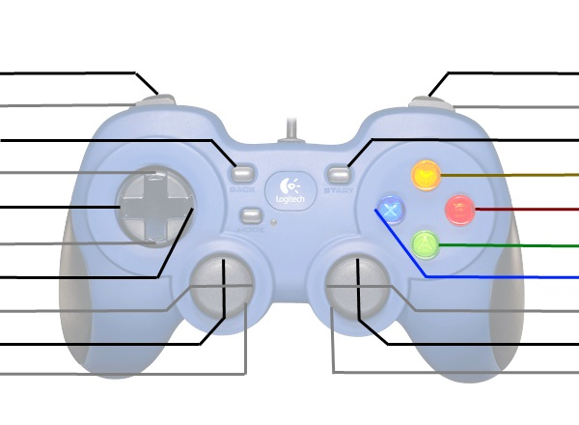

Low Shot Speed

Winch Lower

Reverse Shooter

+ Shooter Speed

High Shot Speed

Shrink Hopper

Winch Lift

Gear Flap

Shoot

Intake

- Shooter Speed